**LAB PROJECT 06**

Oregon Tech

MIS 240: Linux Fundamentals

Ethan Dunzer

8/4/20

NOTE: Just so you know half of these are not answered correctly because I couldn’t figure them out and there was no good method for me to learn how to do it the proper way since there are limited instructions. So now I am stuck not knowing how to properly complete the tasks. And yes I was searching for solutions online but because there isn’t someone doing the same exact thing none of the solutions I found worked. For the record I understand why you do limited instructions and I do agree that in some scenarios it is better; but when there are so many variables and limited concrete information I become stuck not figuring it out and never knowing what the real solution or process is. Then when tested again on that information what am I supposed to do?

1) Cleanup

***Screenshot #1, show your output after using autoremove and autoclean

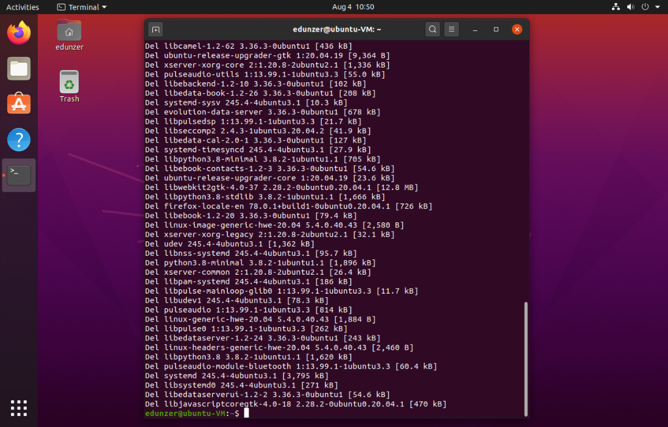

2) Remote Management Setup

***Screenshot #2, show that you’re logged in remotely to your Ubuntu VM using PuTTY from your desktop

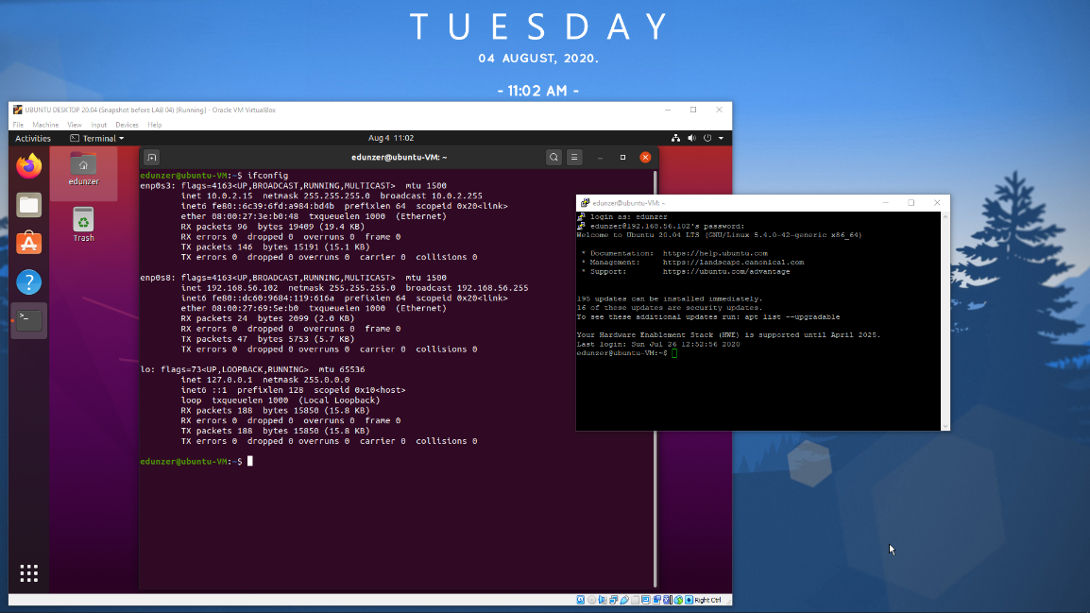

3) SSH with public/private keys

***Screenshot #3, PuTTY screen showing a logged in user after authenticating with the public key

4) MySQL Database setup

***Screenshot #4, show the running status of MySQL

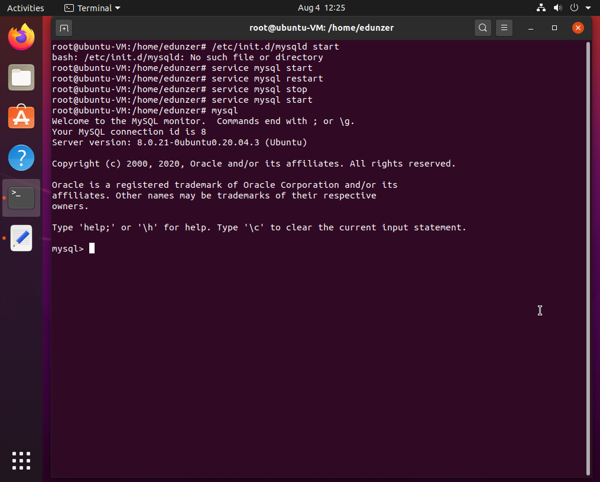

***Screenshot #5, PuTTY output showing grant options for both user accounts

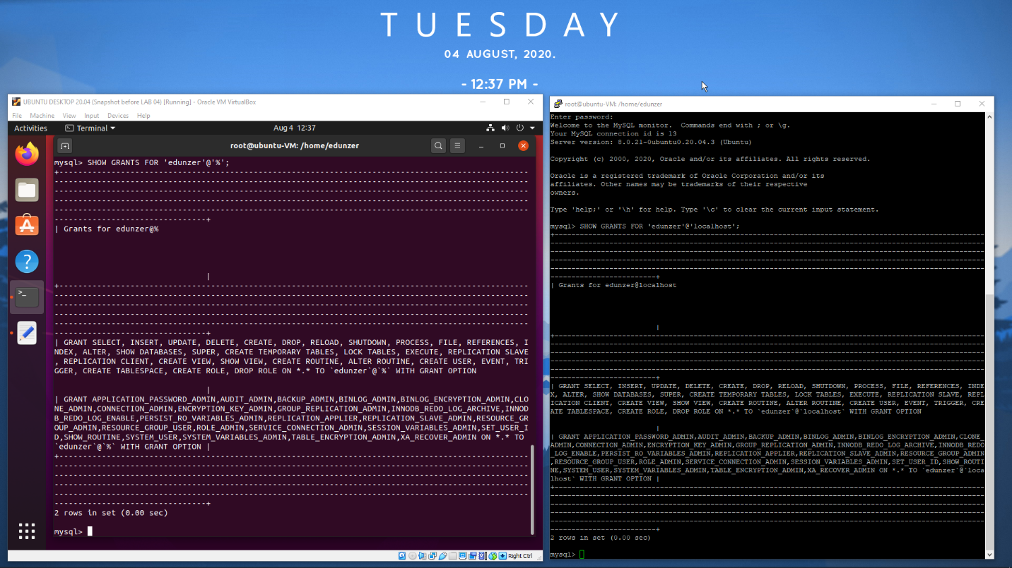

5) Creating a database and table

***Screenshot #6, output showing your students table with an empty set

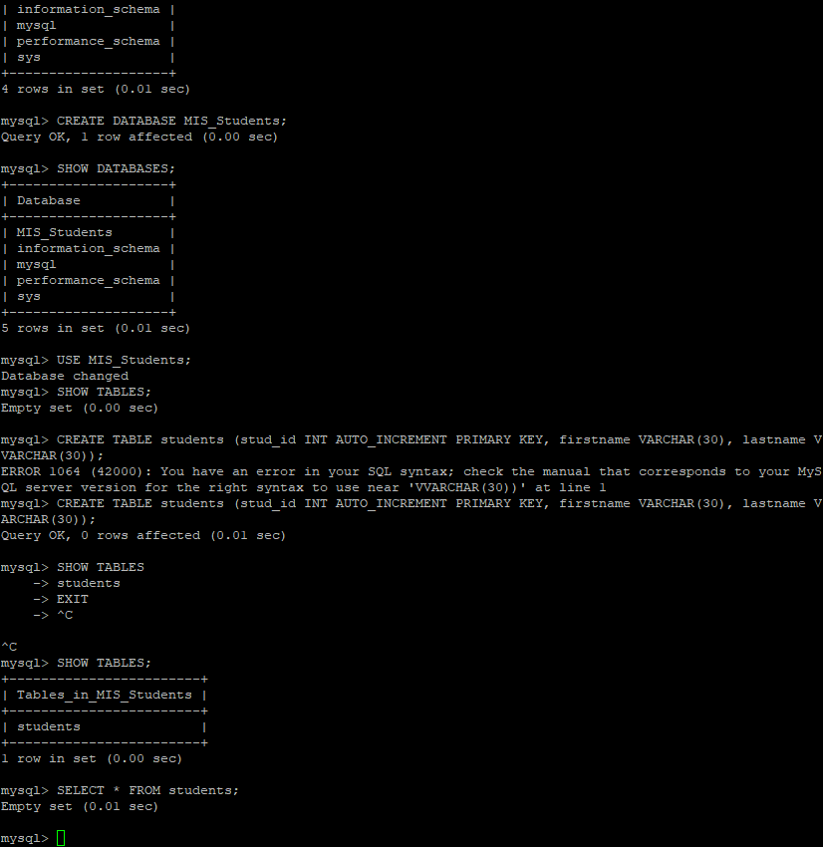

6) Inserting data into MySQL

***Screenshot #7, output showing the three rows entered via the INSERT INTO command

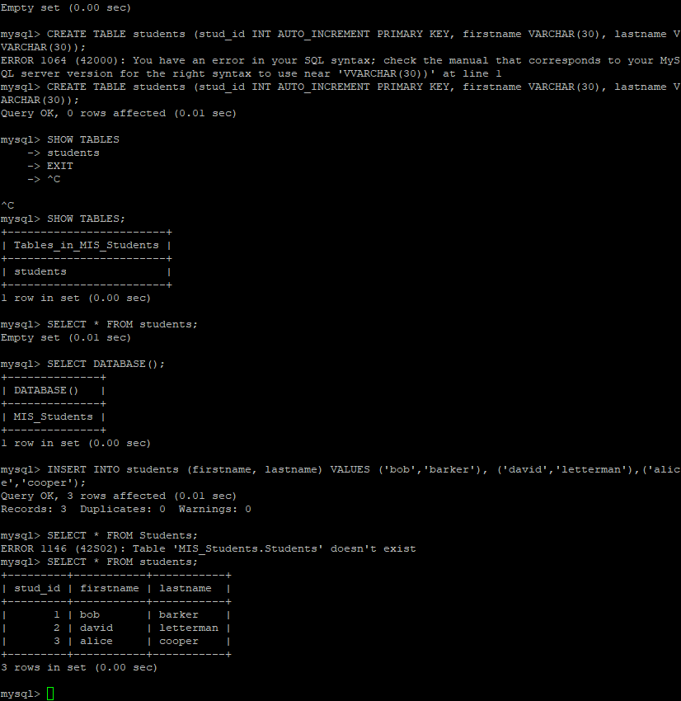

7) Scripting database entries

8) Verifying your work

***Screenshot #8, output showing 13 rows in the students table

9) Using MySQL Workbench

***Screenshot #9, your Workbench window showing your new database and table with columns

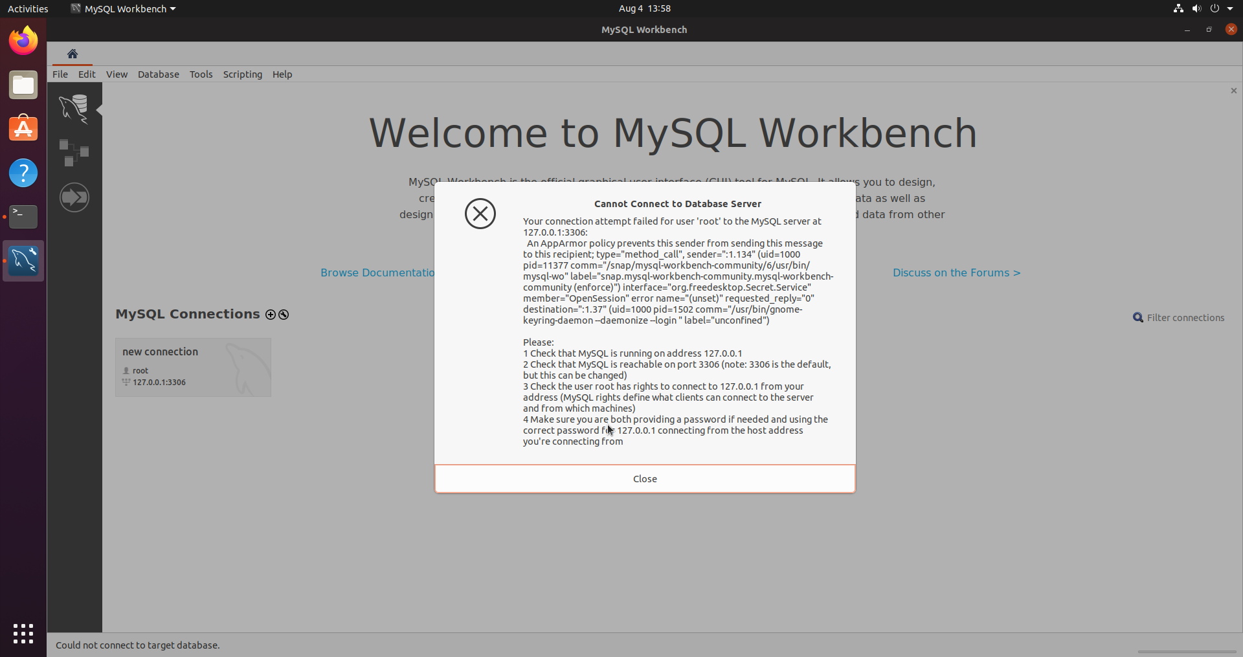

10) Quick Copy

***Screenshot #10, show your host web browser with the contents of your home directory

